North Portland Neighborhood Services
Request for Resident Preference
Your vote needed by Friday, November 5, 2021 a Noon

On September 27, 2021 the Interstate Replacement Bridge Working Committee asked the Hayden Island representative to go back to the community and ask which of 3 interchange options they would prefer for Hayden Island. We have prepared a short google survey. The link to the survey is attached to the bottom of this memo.
The survey question asks which of the following Interstate Interchanges you would prefer and feel free to write your questions and concerns in the comment section. We have asked for your email address on the survey in order to get back in touch with you.
Here are the choices:
1. No Interchange
2. Full Interchange
3. Half Interchange

We realize that there is a lack of available information at this time. However, we ask for your patience and understanding and do your best to answer the question. We will be requesting traffic studies to point out congestion pinch points for the various options for the Marine drive interchanges and local Hayden Island streets.

Note:
All the three options include at least one local access bridge to Hayden Island to and from either Marine Drive, Expo Rd. or the Vancouver Way area. The Interstate Replacement Bridge Committee has not clearly indicated the number of lanes or their purpose.
If you are looking for even more information, the 2017 Washington State Report found at the following link has a lot of information on the bridge and the various possible scenarios: Columbia River I-5 Bridge Planning Inventory Report (wa.gov).

Please Pick from one of these three choices:

A1. Local Access option
The following information shows potential options for Local Access
- All access would be provided by Marine drive ramps to and from Hayden Island.

- If you want to go to Hayden Island you would have to go VIA Marine Drive and across the local access bridge to get to Hayden Island.

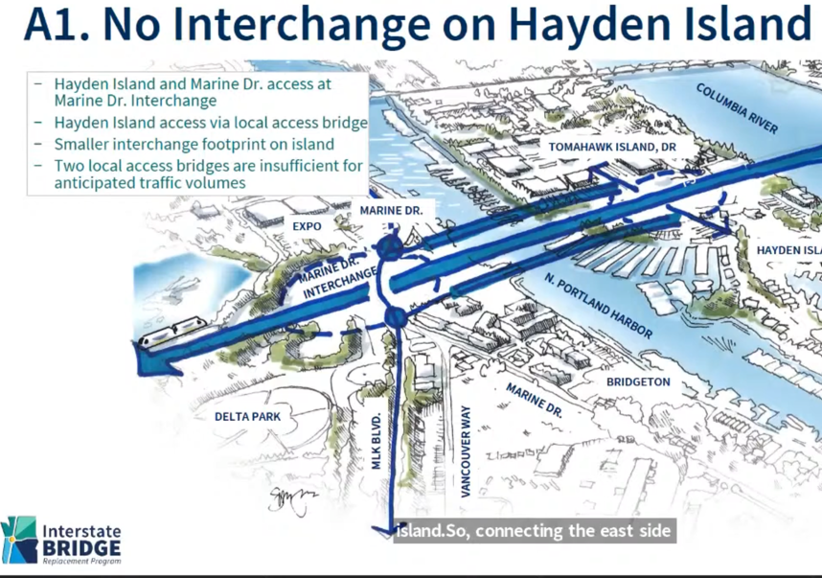

A2. Full Interchange Option
- All access to Hayden Island would be via North and South Interchanges located on Hayden Island.
- Local access connections to Expo Rd. and Vancouver Way will also be included.
- Traffic circulation would be on Hayden Island North and Jantzen Drive South.
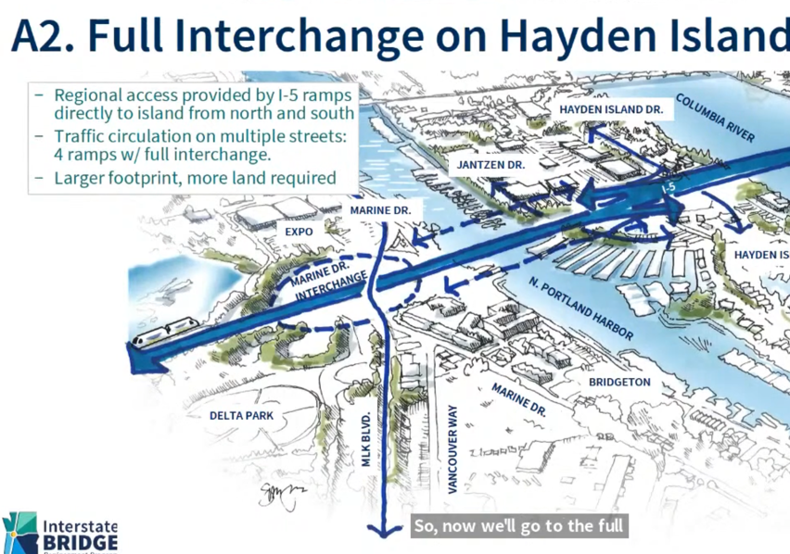

A3. Half Interchange options
- This option would provide ramps to(North) and from (South) Vancouver, WA to Hayden Island only.

- Access to Portland would be via an access road across the North Harbor likely connecting to a proposed Marine Drive interchange (Yet to be determined).

- This option reduces the footprint/land area and impact on Hayden.

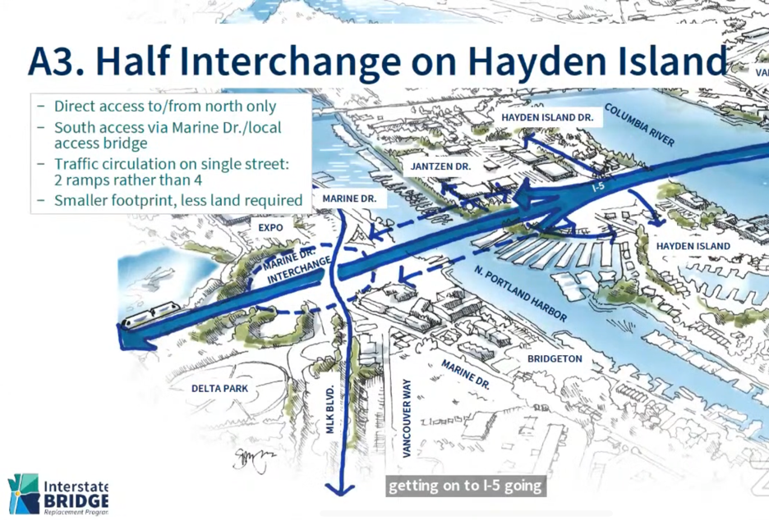

Please click on the link to the survey here

North Portland Survey - Hayden Island Interchange Preference (google.com)

